# CSS 422 Hardware and Computer Organization Sequential Circuits Lab: Storage Registers Instructor Rob Nash

Notes: Pick a group you haven’t yet worked with and attack this part of the lab. Have one person submit this to canvas or in-person when complete.

**Group names:**

**Boyang Zhao**

**Thuan Tran**

**Aaron Vega**

**JD Mauthe**

## Circuits With Memory

Build a 3-bit storage register, just like the registers we’ve discussed in class and the texts. Your circuit should store the value on the input line into its memory when the clock ticks, and this value can be found on the output line following the clock tick. Use D flip-flops. If you know how to make an SR,JK and D-FF, you may use the built-in D flip-flops in Logisim as a black box rather than reinventing the feedback mechanism here.

1. Complete the following state table for the three inputs A,B,C and the three outputs of the D-FFs just following the clock tick.

|  |  |  |  |  |  |
| --- | --- | --- | --- | --- | --- |
| Inputs at Time t | | | Memory Cells at Q(t+1) | | |
| A | B | C | Q2 | Q1 | Q0 |
| 0 | 0 | 0 | 0 | 0 | 0 |
| 0 | 0 | 1 | 0 | 0 | 1 |
| 0 | 1 | 0 | 0 | 1 | 0 |
| 0 | 1 | 1 | 0 | 1 | 1 |
| 1 | 0 | 0 | 1 | 0 | 0 |
| 1 | 0 | 1 | 1 | 0 | 1 |
| 1 | 1 | 0 | 1 | 1 | 0 |
| 1 | 1 | 1 | 1 | 1 | 1 |

1. Do we really need to build an excitation table considering the orthogonal nature of the state table above? Why or why not?

We don’t really need an excitation table considering the D flip flop since the D flip flop only change the output whenever there is a new input

1. Draw the circuit here. Do this by hand before proceeding to Logisim.

Here is my “drew” circuit

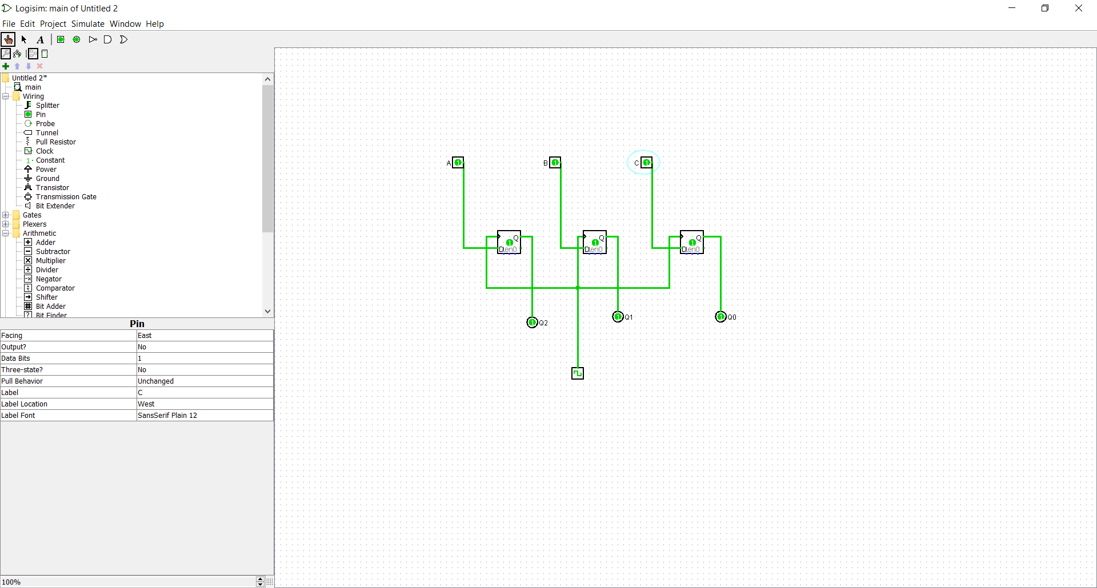

1. Build it in Logisim and test it. Log your output and submit both the circuit file and the logged output.

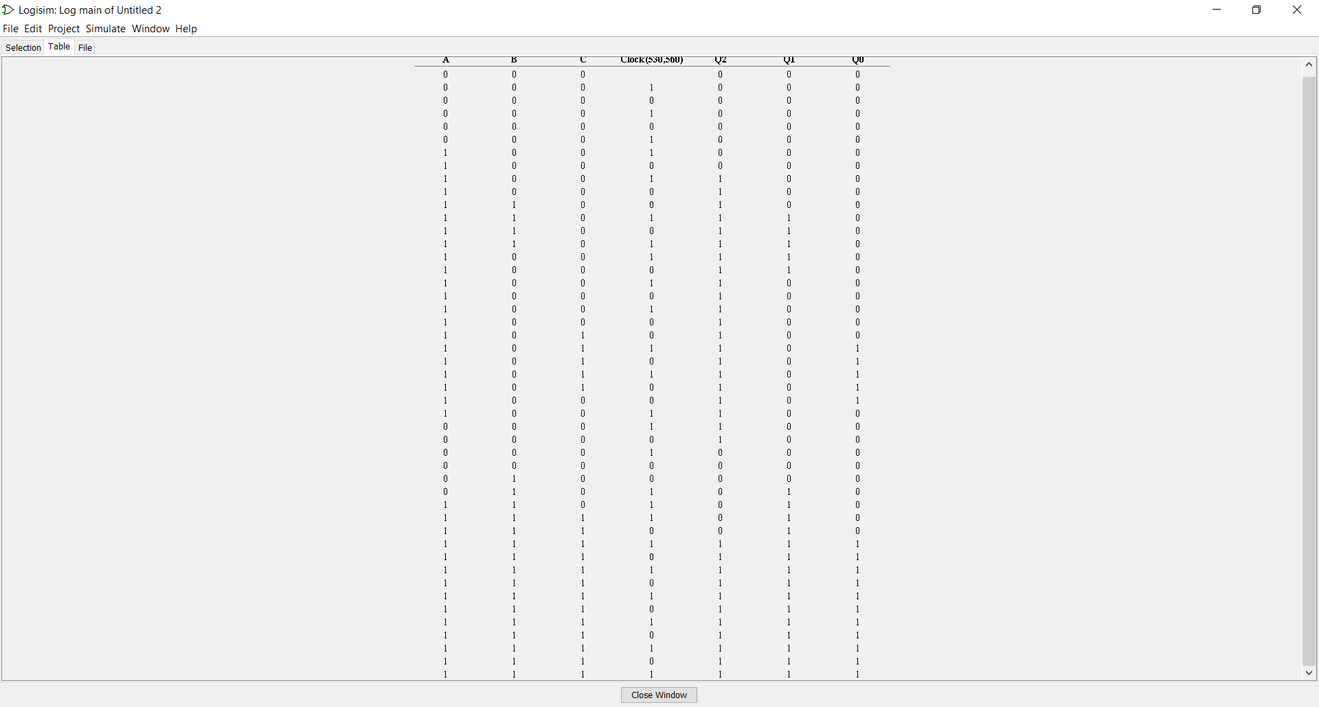

1. If we wanted to extend this register to be an 8-bit register, how would we do it?
   1. What does this imply regarding the hardware, and what would we need to add?
   2. Describe how you would test this circuit?

From 3 bit to 8 bit register => add another 5 D flipflops. This imply that to increase the ability to store bit, we just need more small components and attach them together

b) Like above, logging or manually “poking” the input and clock

1. Build the 8-bit register in Logisim and submit it.

